CIE-USA/DFW

MathComp 2015

Grade 7

40 +2 questions

Time: One Hour

Note:
- Make sure to write all your answers on the answer
sheet. Only the answer sheet will be graded.
- Each question only has one correct answer.
- Print your name clearly and legibly below.

Name ___________________
Room ___________________

- For what value of x if = + 2

A. 0 B. C. D. E. Not real number

- Which of this following expressions is equivalent to 9k²?

I.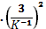 II.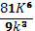 III.

- None
- II Only
- III Only
- I and III only
- I, II and III.

- In the expression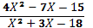, which of the following CANNOT be the value of x?
- - and 3
- -6 and 3
- -6 only
- 3 only
- - only

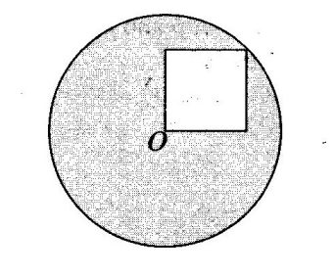

- In the figure above, the square is internally tangent to the circle with center O. If a side of the square has length 4, and O is a vertex of the square, then what is the area of the shaded region?

- 36π – 4
- 32π – 16
- 32π
- 12π – 4
- 24π – 16

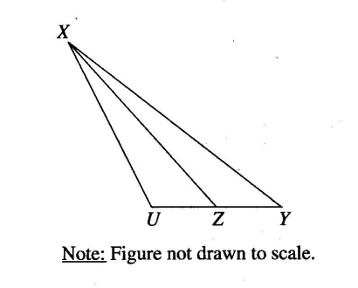
- If the length of UZ is 25% of the length of UY and the area of ∆XYZ is 201, what is the area of ∆UXZ?

- 67 B. 804 C. 840 D.1080 E.1240

- The area of a rectangle is $\text{30}m^{\text{11}}n^{5}$square units. If the length of the rectangle is $5m^{4}n^{2}$ units, how many units wide is the rectangle? ($m≠0$and $n≠0$)

A. $6m^{7}n^{3}$ units
B. $\text{35}m^{7}n^{3}$ units
C. $6m^{7}n^{3}$ units
D. $\text{16}m^{7}n^{3}$ units
E. $\text{25}m^{7}n^{3}$ units
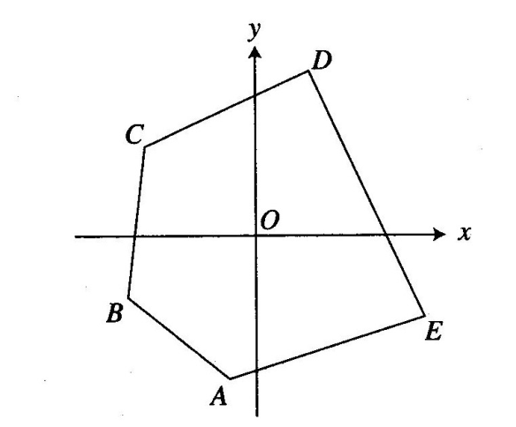

- In the figure above, how many lines with positive slope can be drawn containing point O and a vertex of pentagon ABCDE?

A. 3
B. 4
C. 5
D. 6
E. 0

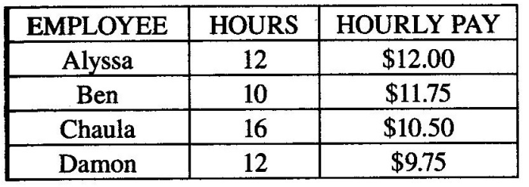
- The chart above payroll for four employees for the week ending May. How much more money did Chaula earn than Alyssa?
- $1.5
- $4.00
- $18.00
- $24.00
- $30.00

- If x=3712, y=2138, then $\frac{x+|x−5y|+|4x−5y|}{\frac{4x}{y}}=?$

A. 2138
B. 3712
C. 3713
D. 2137
E. 3711

- In the distance formula $d=\text{rt}$, r represents the rate of change, or slope. Which ray on the graph best represents a slope of 66 mph?

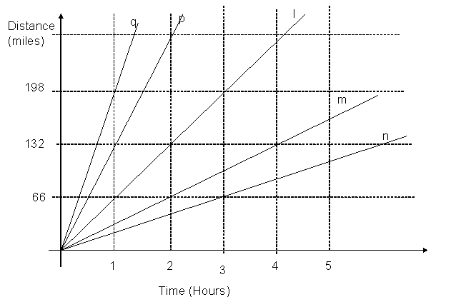

A. l
B. m
C. n
D. p
E. q

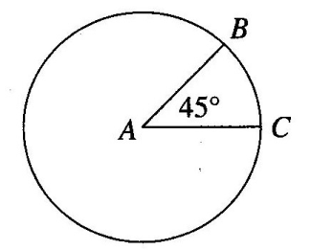
- Points Band C lies on a circle with center A. If the length of arc BC is 20, what is the perimeter of sector ABC?

- 20 +
- 20 +
- 20 + 160π
- 10 + 20

- A recipe for 10 waffles calls for $1\frac{1}{2}$ cups of milk, $2\frac{1}{4}$ cups of flour, and $1\frac{1}{3}$ cups of other ingredients. How many cups of milk, flour, and other ingredients are needed to make 40 waffles?

A. $\text{20}$
B. $\text{20}\frac{1}{3}$
C. $\text{20}\frac{2}{3}$
D. $\text{21}\frac{1}{3}$
E. $\text{21}\frac{2}{3}$

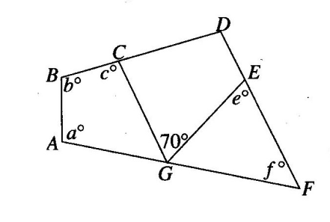

- In the figure above, what is the value of a + b + c + e + f?

- 130
- 230
- 330
- 430
- 530

- Find the missing number: $\frac{1+2}{3}+\frac{4+5}{6}=\frac{7+8}{9−?}$

A. 1
B. 2
C. 3
D. 4
E. 6

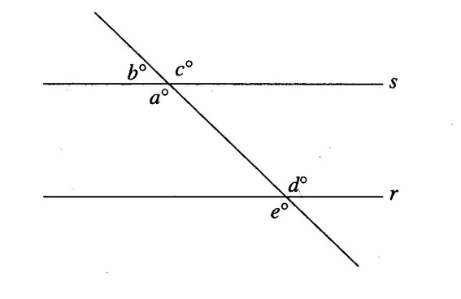

- In the figure above, r||s, and a=130. What is the sum of b, c, d, and e?
- 270
- 360
- 440
- 520
- 610

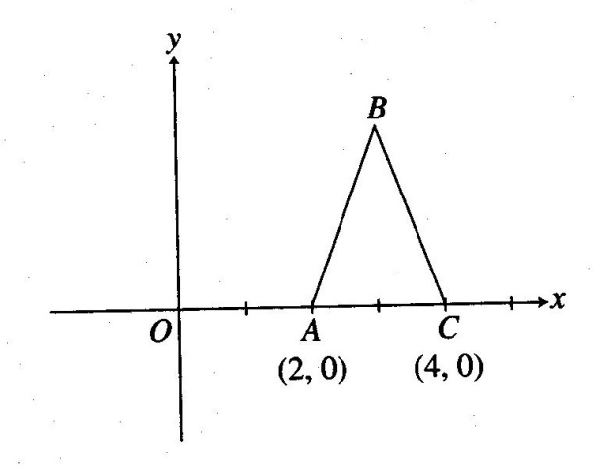

- Isosceles ∆ABC, shown above, has an area of 10. If AB=BC, what is the coordinate of point B?

- (2, 3)
- (2, 5)
- (3, 6)
- (3, 8)
- (3, 10)

- Solve $−\frac{s+5}{3}>\frac{2−3s}{6}$

A. $s>−8$
B. $s>−\frac{8}{5}$
C. $s<−\text{12}$
D. $s>\text{12}$
E. $s<−\frac{5}{8}$

- The school auditorium was $\frac{7}{8}$ full. What percent of the auditorium was full?

A. 0.875%
B. 0.125%
C. 88.5%
D. 0.885%
E. 87.5%

- , then ___.

A. 49
B. 64
C. 81
D. 16
E. 153

- 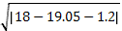 = ?

A. 1.5
B. -1.5
C. 2.5
D. -2.5
E. 3.5

- (9x² –y²)(x²- 6xy+5y²) = ?

A. $(x+y)(x−5y)(3x−y)(3x+y)$
B. $(x−y)(x−5y)(3x+y)(3x+y)$
C. $(x−y)(x−5y)(3x−y)(3x+y)$
D. $(x−y)(x−5y)(x−y)(9x+y)$
E. $(x+y)(x+5y)(3x−y)(3x+y)$

- The school meeting is on the 209th days of the calendar year, in __.

A. May
B. June
C. July
D. August
E. September

- This Venn diagram is used to classify counting numbers according to a set of rules. Which one of the following numbers belongs in the region of the diagram made by the question mark?
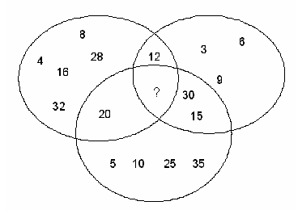

A. 25
B. 35
C. 50
D. 55
E. 60

- Ten years ago, the sum of the ages of Ted and his twin brother Todd was 24. How old is Ted now?

- 15
- 16
C. 22
D. 32
E. 42

- In the graph of the function y = 2x² + 3, which described the shrift in the vertex of the parabola if, in the function, 3 is changed to -4?

A. 3 units down
B. 7 units down
C. 7 units up
D. 3 units up
E. None of above

- We know a, b, c are integers, and have a>b>c, which of following relation is true:
A. ab > bc
B. a-b > b-c
C. >
D. a+b > b+c
E. None of above.
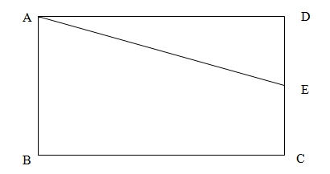

- In a rectangle, 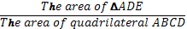 = . What is the ratio of the length of segment to the length of segment?

A. 2/3 B. 3/4 C. 2/7 D. 1/2 E. 5/2

- If f(x) = x² and g(x) = f(x-3), then for what value of x does f(x) = g(x-1) ?.

A. 10 B. 8 C. 6 D. 4 E. 2

- In a lottery drawing, tickets will be drawn at random from a hat. If 1/8 of tickets in the hat are green, ½ are white, ¼ are blue, and the remaining 30 tickets are pink, how many blue tickets are in hat?

A. 30 B. 60 C. 90 D. 120 E. 200

Degree – Radians Conversion
Degrees | 0 | 90 | 180 | 360 | 720
Radians | 0 | Π / 2 | Π | P | 4Π

- In the table above, what is the value of P?
- 1 B. C. 2 D. E. 3π

x | f(x)
0 | 16
1 | 4
2 | 1
3 | ¼

- The chart above shows selected values for function f. if f(x) = cr^{x}, where c and r are constant, what is f?
- ¼
- 2
- 4
- 16
- It cannot be determined from the information given.

- If x and y are positive integers and 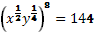, what is the smallest possible value of x - y?

- 4
- 1
- 0
- -1
- -4

- Which parallelogram is congruent to parallelogram ABCD?

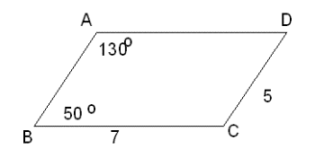

A. 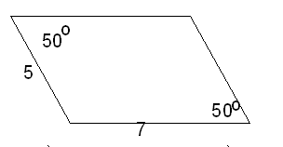
B . 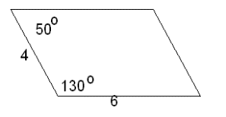
C. 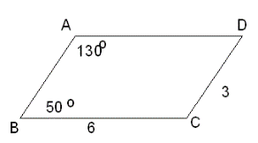
D. 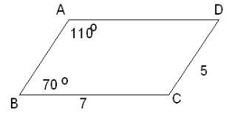
E. 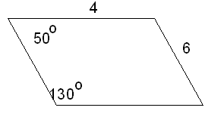

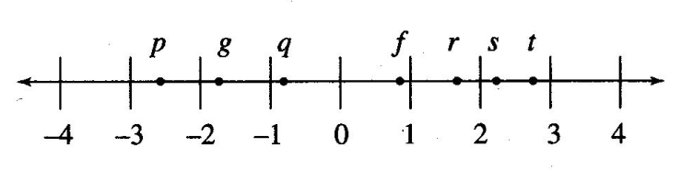

- If the letters on the number line above are the coordinate of the indicated points, then f – g is close to

- p B. q C. r D. s E. t

- If the function p is defined by p(x) = ax² + bx + c, b<-3 and 2<ab<4, and c>30. Which of the following could be the graph of y=p(x)?

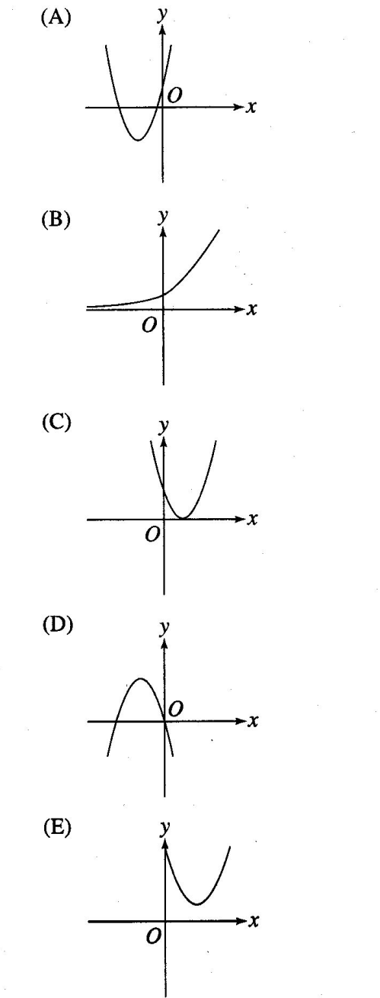

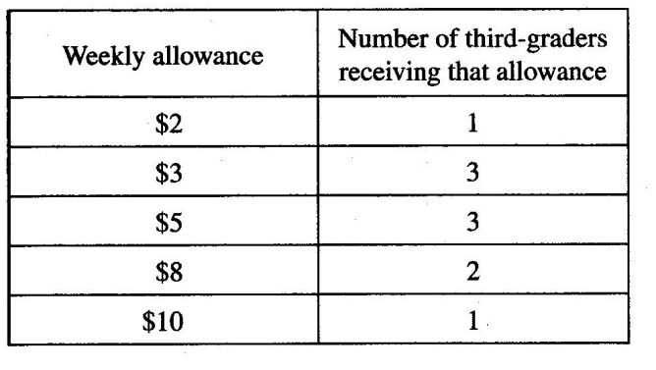
- A study recorded the weekly allowances received by 10 third-graders, as shown in the table above. What is the average(arithmetic menu) weekly allowance received by a third-grader in the study?
- $5.00
- $5.20
- $5.60
- $6.00
- $6.20

- What’s the last digit [units digit] of
. 3 B. 1 C. 9 D. 7
A. 3
B. 1
C. 9
D. 7
E. 5

- A rectangle has a length of 3x - 2 and a width of 6x + 3, which expression best describes the area of the rectangle?

A. $9x−1$
B. $\text{18}x−2$
C. $\text{18}x^{2}−3x−6$
D. $\text{18}x^{2}+3x+6$
E. $\text{18}x^{2}+3x−6$

- David budgets $2100 of his job earnings on a monthly basis. The graph below shows his monthly budget, which conclusion can be drawn from the information given?

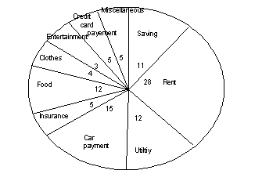

A. More than 30% of David’s budget is for credit card payments, insurance, and food combined
B. David budgets $ 672 for utilities, insurance, and his card payment combined.
C. Less than 50% of David’s budget is for rent, food, and utilities combined.
D. David budgets $378 for savings, entertainment, and clothes combined
E. None of above.

- In the sequence 5, 4, 3, 7,1,2,5,4,3, 7,1,2,5,4,3, 7,1,2,5,4,3,……, following this pattern, what is the 2008th number?

A. A. 7 B. 1 C. 3 D. 5 E. 4

Bonus Questions:

41. If , , and are consecutive positive integers such as v < w <x < y <z, then wy =

A. x²
B. x² -1
C. x² - 2
D. x² - 3
E. x² - 4

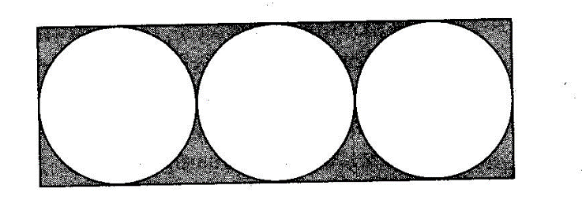
42. The figure above shows the pattern used to lay rectangular tiles of equal size in a certain floor. Each tile has three inscribed tangent circles. If the radius of each circle is r and the area of the floor is 480r², what is the area of the floor that is shaded?

A. 12r² – 3πr²
B. 40(12r² – 3πr²)
C, 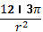
D. 160(12r² – 3πr²)
E. 480r² – 3πr²

