CIE-USA/DFW

Math Competition 2015

Grade 6

30 questions

45 minutes

Notes:
-Make sure to write all your answers on the answer sheet. Only the answer sheet will be graded.
-Each of the 30 questions carries the same weight, so if you get stuck on one question, move on and work on the easier problems first.
- PRINT your name and room below.

Name ___________________

Room ___________________

1. Evaluate

A. 511 B. 512 C. 1023 D. 1024 E. 2047

2. What is the product of the least common multiple and the greatest common factor of 98 and 102?

A. 4 B. 100 C. 200 D. 2499 E. 9996

3. Jennifer started the number pattern shown below. What is the sixth number in her pattern?

1, 3, 13, 63, ...

A. 313 B. 315 C. 1563 D. 1565 E. 7823

4. Find the measure of the length of AB in the diagram.

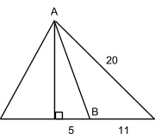

A. 10 B. 11 C. 12 D. 13 E. 14

5. How many ways can 3 letters be posted in 5 post boxes, if any number of letters can be posted in all of the three post boxes?

A. 15 B. 124 C. 125 D. 242 E. 243

6. How many squares of any size are in the figure shown?



A. 83 B. 84 C. 85 D. 86 E. 87

7. 2²⁰¹⁵ = 2²⁰¹³ + 2²⁰¹³ + _______.

A. 0 B. 2015 C. 2²⁰¹² D. 2²⁰¹³ E. 2²⁰¹⁴

8. Which of the following times is the closest to when the hour hand and the minute hand on an analog clock coincide for the first time after 2:00 pm?
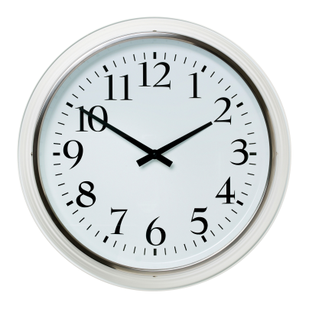
A. 2:10 pm B. 2:11 pm C. 2:12 pm D. 2:13 pm E. 2:14pm

9. Each of three marbles A, B, and C is exactly one color. One marble is white, one is red, and the last one is blue. Only one of the following statements is true.

A) A is red.
B) B is not blue.
C) C is not red.

What color is marble B?

A. Red B. Blue C. White D. Purple E. Not possible

10. and are both perfect squares greater than 100. If , what is the value of ?

A. 1 B. 3 C. 11 D. 33 E. 99

11. Suppose m and n are positive odd integers. Which of the following must also be an odd integer?

A. B. C. D. E.

12. Paul and Paula each start at Point A. They are racing to get to Point B. Paul decides to go through Point C, and Paula decides to take the route through Point D. Assuming that they run at the same speed and start at the same time, turning takes no time, and all angles in the figure are right, who will get to Point B first?

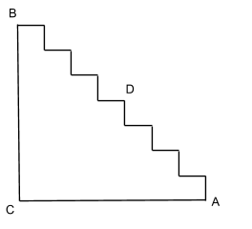
A. Paul B. Paula C. Same D. Neither E. Not enough info

13. Bob went to the market and got 4 apples and 5 mangoes for $35. Joe went with him and bought 6 apples and 3 mangoes for $39. Find the total cost of 24 apples and 24 mangoes.

A. $144 B. $168 C. $192 D. $216 E. $240
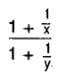
14. If 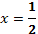 and 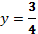, find the value of .
A. 6/7 B. 1 C. 8/7 D. 9/7 E. 10/7

15. A multiple choice examination consists of 25 questions. The scoring is +5 for each correct answer, -2 for each incorrect answer, and 0 for each unanswered question. John's score on the examination is 74. What is the maximum number of questions he could have answered correctly?

A. 15 B. 16 C. 17 D. 18 E. 19

16. Find the value of ……..

A. 1/10815 B. 1/3605 C. 3/3605 D. 1/105 E. 1

17. The length of a rectangle is 2 times its width. The diagonal is 15 cm long. What is the area of this rectangle?

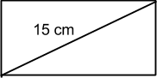

A. 45 B. 60 C. 75 D. 90 E. 105

18. Corner A of a rectangular piece of paper of width 8 inches is folded onto point C on the opposite side. If BC =5 inches, find the length of the fold .
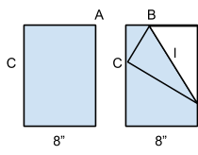

A. 8 in B. in C. 12 in D. 13 in E. 14 in

19. ?

A. B. C. D. E.

20. Consider the following pattern:

Determine .

A. 2501 B. 2551 C. 2601 D. 2651 E. 2701

21. There are 130 sixth-graders at Davis Middle School. Eighty-five are in band, and fifty-two attend the math club. Sixteen students are in neither of the two clubs. How many students are in both band and the math club?

A. 3 B. 13 C. 23 D. 33 E. 43

22. The mean of the integers 7, x, 2x-3, and 9 is 7. What is the smallest integer?

A. 3 B. 4 C. 5 D. 6 E. 7

23. In a warehouse, there are two identical barrels of oil. One barrel is full, and the other is half full. Their weights are 86 and 53 pounds, respectively. How much does an empty barrel weigh?

A. 10 B. 15 C. 20 D. 25 E. 30

24. If (k-1)x + 3k = ax + 6 for all values of x, in which k and a are constants, what is the value of a?

A. -2 B. -1 C. 0 D. 1 E. 2

25. In how many integers from 1 to 200, inclusive, does the digit 9 appear at least once?

A. 18 B. 20 C. 25 D. 37 E. 38

26. An 8x11 sheet of paper has 1-inch margins on all sides. What fraction of the area of the sheet is taken up by the margins?

A. 9/44 B. 17/44 C. 27/44 D. 35/44 E. None of the above

27. The Itsy-Bitsy spider climbed up the 10-foot spout on the side of your house. Every day, she climbed exactly 2 feet, and every night, she stopped to rest. However, every night at 10:00 pm when she rested, a current of water flushed down the spout and pushed her down a foot. Once she got to the top, the Itsy-Bitsy spider immediately left to climb your neighbor’s spout. If she started at the bottom on Day 1, on which day did she leave the spout?

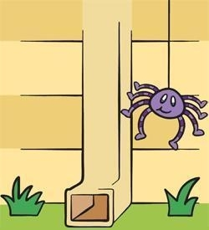

A. Day 7 B. Day 8 C. Day 9 D. Day 10 E. Day 11

28. There are 3 circles and 4 lines in a plane. What is the maximum number of points of intersection in the plane?

A. 12 B. 18 C. 24 D. 30 E. 36

29. The sum 101+102+103+…+150 is greater than the sum 51+52+53+…+100 by ___.

A. 2000 B. 2250 C. 2500 D. 2550 E. 5000

30. What is the smallest possible value of ?

A. 5 B. 6 C. 12 D. 15 E. 21
BONUS QUESTIONS:

31. In the sequence

4, 6, 2, -4, -6, -2, 4...

What is the value of the 2015th term?

A. -6 B. -4 C. 2 D. 4 E. 6

32. Four cubes with edge lengths 1, 2, 3, and 4 are stacked as shown. What is the length of the portion of contained in the cube with edge length 3?
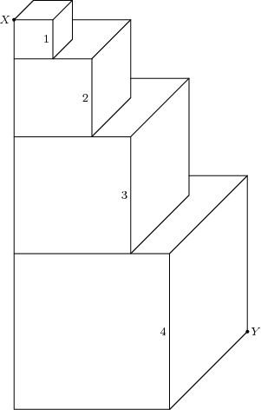
A. 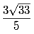 B. C. 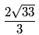 D. E.

