CIE-USA/DFW

MathComp 2015

Grade 5

40 questions

Time: One Hour

- Make sure to write all your answers on the answer
Sheet. Only the answer sheet will be graded.
- Each question only has one correct answer. The difficulty of the question is randomly distributed.
- Print your name clearly and legibly below.

Name ___________________

Room ___________________

- Which of the following fractions is the equivalent of 5/7?

- 12/17
- 9/14
- 10/18
- 10/14

- Change 0.68 to a fraction
A. 1/68
B. 6/8
- 26/68
- 17/25

- If there were 300 people at a dinner and nearly 39% ordered fish, approximately how many ordered fish?
- 200
- 150
- 120
- 110

- A rectangle has length of 170m and width of 100m; Find out the area.
Fig 4. 170 m

100 m

- 170 m
- 1700 m
- 17000 m²
- None of the above

- There are five Mondays and four Tuesdays in August of a year. What day is August 8th of that year (August has 31 days)?

- Tuesday
- Thursday
- Saturday
- None of above
- The LCM (Least Common Multiple) of 2 and 7 is 14. What is the LCM for 4, 7, and 42?
- 294
- 1176
- 84
- None of the above

- Jessica weighed a beaker filled with liquid. If the beaker and the liquid weighed 15.478 grams and she spilled out 6.9 grams of liquid. How much do the beaker plus the liquid weigh now?
A. 15.478
B. 22.378
C. 8.578
D. 6.9

- If it takes one minute to make a cut, how long will it take to cut 32 yards of cloth to 8 equal lengths, cutting 1 piece at a time?
- 4 minutes
- 5 minutes
- 6 minutes
- 7 minutes
- 8 minutes

- Jason was buying treats for 28 kids for his birthday party. He was told that 10 cookies and 18 scones will cost $36, but 15 cookies and 13 scones will cost $40. How much is one cookie?
- 1.8
- 2.1
- 2.4
- None of the above

- A dinner table is composed of a rectangle and a semi-circle (see Figure 11). The length of rectangle is 12 ft. and the radius of the circle is 4 feet. The surface area of this table is: (in terms of π)

- 96+8π square feet
- 120+16π square feet
- Not enough information to solve it

Fig 11.
A
D
PD

rD

BD
CD
- The average value of 10 numbers is 789. The average of eight of those ten is 678. Find the average of the other two numbers.

- 1183
- 1233
- 1323
- 2466

- Tom walked a total of 65 miles for 5 days. Every day he walked 4 miles less than the day before. How many miles did Tom walk the last day?

  - 4 miles
  - 5 miles
  - 6 miles
  - 10 miles
  - None of the above

- What is the surface area of the box formed by the pattern below?

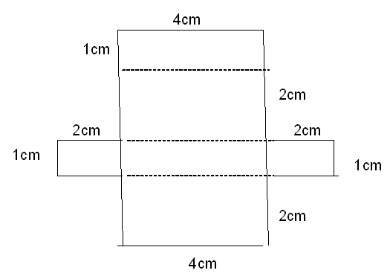

- Alice talked on the phone with two friends. She talked to Sherry for 2 1/2 hour, and to Gabriel for 30 minutes. How much time did Alice spend on the telephone?

- 2 Hours.
- 2 and half Hours.
- 3 Hours.
- None of the above

- Which equation could have been used to create this function table?

x | y
-1 | -1
1 | 3
2 | 5

- Y= -1+X
- Y= 1- X
- Y= 1+2X
D. X and Y have no relationship

- Out of a sample of 450 people, 8% were vegetarians. How many were not vegetarians?

  - 360
  - 414
  - 280
  - 524
  - None of the above

- The table shows the annual profit for five companies. Which statement is valid about the annual profit of these five companies?

Company | Profits
I | $300,000
II | $285,000
III | $260,000
IV | $335,000
V | $210,000

- Companies II and V made the same profit.
- No company made less than $285,000 in profits.
- No company made more than $310,000 in profits.
- Company IV made $85,000 more in profits than company III.
- None of above

- Find the value of the expression a+6 when a= - 8

- 2
- 6
- -8
- -2

- On a map, 2 cm = 7 miles. What is the actual distance of a sidewalk that measures 10 cm on the map?

- 14 miles
- 28 miles
- 35 miles
- 65 miles
- None of above

- The pie chart below shows the distribution of vacation destinations for students attending Arlington High School.

Vacation Destinations

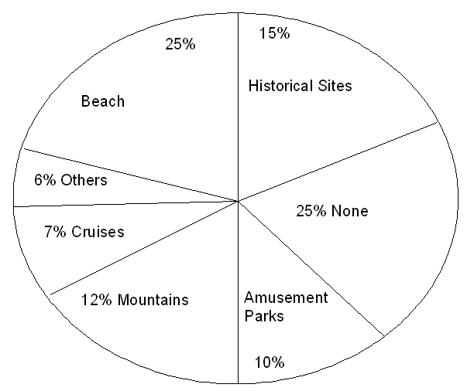
If 600 students attend Arlington High School, how many are going to the mountains for vacation?

- 76
- 75
- 74
- 73
- 72

- Find the value of 8⁷ × 6⁹ × 5⁰ ÷ (8⁵×6⁸ )

  - 38
  - 48
  - 384
  - 348
  - Cannot be decided.

- Point O is on the line segment AB. BOC is 90º. BOD: COD=4:1. Find AOD.
C
D
  - 25
  - 30
  - 60
A
B
  - 75
O
  - None of above

- Initially it took a machine 16 minutes to fill 300 bottles of soda. After technology improvement, the machine can fill twice as fast as before. How many minutes does it take the machine to fill 750 bottles of soda after the improvement?

  - 16 minutes
  - 20 minutes
  - 32 minutes
  - 40 minutes

- The rectangle shown below has a length of 17 inches and perimeter of Q inches. Which equation could be used to find the width (w) of the rectangle?

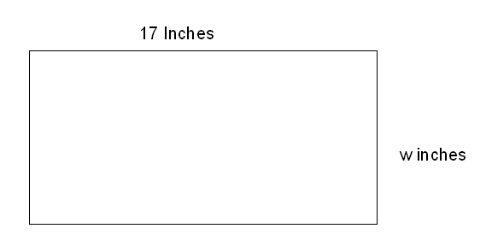
  - W=1/2 (Q-34)
  - W=Q/2-34
  - W=Q-34
  - None of the above

- The sale ad read: “Buy three tires at the regular price and get the fourth tire for $3.” Tom paid $240 for the set of four tires at the sale. What was the regular price of one tire?
  - $59
  - $79
  - $80
  - Cannot be decided

- Find 7% of 430. Round off the answer to the nearest whole number.

  - 30
  - 40
  - 50
  - 60
  - None of the above

- If there were 300 people at a dinner and nearly 40% ordered fish, approximately how many ordered fish?

- 200
- 120
- 150
- 110
- 90.

- Figure ABCD is a parallelogram and the area of is 30 square feet.
The length of CD is 15 feet; AH is the height of ABCD. Find the length of AH.
A
B
Fig 29-

h
D
- 3
C
H
- 4
- 5
15feet
- 6

- Find the value of N that completes the equation 3N-5=N+17

- 10
- 1
- 13
- None of the above

- What is the complement of (3X)⁰

- (180-3X)⁰
- (100-3X)⁰
- (90-3X)⁰
- (3X)⁰
- None of the above

- What is the prime factorization of 504?

- How many ounces does a one and quarter pound hamburger patty weigh?

- 10
- 18
- 20
- None of the above

- What is the supplement of (9b)⁰

  - (100+9b)⁰
  - (180-9b)⁰
  - (90-9b)⁰
  - (100-9b)⁰

- If the length, width, and height of a box are , respectively, 8 ^{cm}
, 7 ^{cm} , 4.6 ^{cm} . find its volume.
  - 257.6 cubic cm
  - 258 cubic cm
  - 56 cubic cm
  - None of the above

- Multiply (+3) (-2) (-1) (+4)
  - -24
  - -12
  - +24
  - +12
  - 20

- Change 4.05 × 10³ to a whole number.
- 40.5
- 405
- 4,050
- 40,500
- 405000

- A movie starts at 1:00pm and lasts 190 minutes. When will the movie end?

- 3:40pm
- 3:45pm
- 4:10pm
- 4:30pm

- Divide 229.862 by 5.26

  - 43.62
  - 43.6
  - 47
  - 43
  - 43.7

- Multiply 4.56 by 13.7 and round the answer off to the nearest tenth

  - 62.472
  - 62.47
  - 62.5
  - None of the above

- A jar contains 6 blue marbles, 7 red marbles, and 2 white marbles. without looking find P (blue).
- 3/15
- 6
- 2/5
- 10
- 12

BONUS QUESTION:

- Each of the equal sides of an isosceles triangle is 7 and its base is 2 more than the base of an equilateral triangle. If the perimeters of the two triangles are equal, find a side of the equilateral triangle.
  - 8
  - 5
  - 9
  - 6

