CIE-USA/DFW

Math Competition 2015

Grade 2

30 questions

45 minutes

Notes:
-Make sure to write all your answers on the answer sheet. Only the answer sheet will be graded.
-Each of the 30 questions carries the same weight, so if you get stuck on one question, move on and work on the easier problems first.
- PRINT your name and room below.

Name ___________________

Room ___________________

1. What is the sum of the first 10 positive odd numbers?

A. 45 B. 55 C. 100 D. 110

2. Today is February 1 and a Wednesday. How many Saturdays are there this February?

A. 4 B. 5 C. 6 D. 7

3. Which are the three missing numbers?
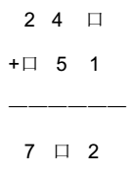
A. 1, 4, 5 B. 1, 5, 6 C. 1, 5,9 D. 1, 1, 4

4. If you have 600 hundred-dollar bills, you have

________thousand dollars.

A. 60 B. 600 C.6000 D. 60,000

5. 42 seven-year olds and 7 forty-two-year olds gather in a room. What is the average age in the room?

A. 7 B. 12 C. 24.5 D. 42

6. Find the sequence and fill in the blank.

1, 3, 4, 7, 11, __,

A. 16 B. 17 C. 18 D. 19

7. How many tens can we add to 758 without going over 822?

A. 4 B. 5 C. 6 D. 7

8. How many triangles are there in the following drawing?
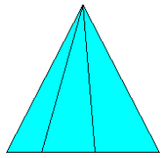
A. 3 B. 4 C. 5 D. 6

9. The Yummy Tummy Restaurant boasts a menu of 2 appetizers, 3 entrees, and a number of desserts. A meal consists of an appetizer, an entree, and a dessert. If there are 12 possible meal choices, how many dessert choices are there?

A. 2 B. 3 C. 4 D.5

10. Mr. Jordan’s class is going on a field trip to the Children’s Theater on vans. The class has 81 students. If each van holds 10 students, how many vans were needed?

A. 7 B. 8 C. 9 D. 10

11. I am an integer greater than 15. If you multiply me by 5, you will get a number less than 90. If you divide me by 4, you will get an integer. What am I?

A. 16 B. 17 C. 18 D. 20

12. Look the the pattern below. More vertical columns are added to the right following the same pattern, until the last column is 7 squares tall. How many squares are there in total?
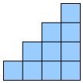
A. 20 B. 28 C. 50 D. 55

13. 19 children line up in a row. If Kate is number 8 from the front of the line, what is her number counting from the back of the line?

A. 9 B. 10 C. 12 D. 13

14. James is tiling his square kitchen with square tiles. If each tile is to have a side length of 6 inches and his kitchen has a side length of 10 feet, how many tiles will he need? (Hint: one foot has 12 inches.)

A. 4 B. 64 C.144 D. 400

15. If it takes 3 minutes for three kids to eat 3 apples, how long would it take for 6 kids to finish eating 6 apples?

A. 3 B. 6 C. 10 D. 18

16. If Alice saves $2 a day, how much will she have saved in 10 weeks?

A. 20 B. 40 C. 70 D. 140

17. The following diagrams represent fruits on balances. Which fruit is the heaviest?
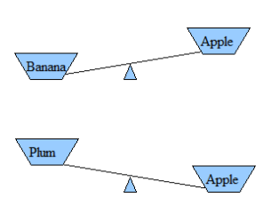
A. Apple B. Banana C. Plum D. Orange

18. Jack is thinking of 2 numbers whose sum is 130 and whose difference is 40. Find the numbers.

A. 90, 50 B. 85, 45 C. 80, 50 D. 80, 40

19. David wants to play tennis with Juan on a Sunday afternoon. There are 2 different roads from David's house to Juan's house. There are 3 different roads from Juan's house to the tennis courts. If David wants to meet Juan at his house and then walk to the tennis courts, how many different ways can David get to the tennis courts?
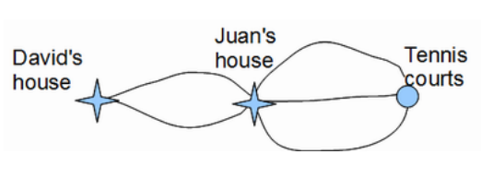
A. 5 B. 6 C. 7 D. 8

20. It took Zack's family 7 hours and 10 minutes to drive to Disneyland. If they started at 6:30 am, what time did they arrive?

A. 12:40 pm B. 1:10 pm C. 1:40 pm D. 2:10 pm

21. If today is Thursday, what day of the week is 28 days from today?

A. Monday B. Tuesday C. Wednesday D. Thursday

22. Dirk Nowitzki scored 24 points in one game. How many points will he need to score the next game to score an average of 28 points over the two games?

A. 20 B. 24 C. 28 D. 32

23. How many more faces are on a cube than are on a cylinder?
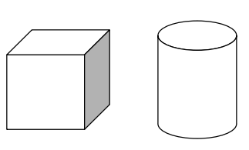
A. 1 B. 2 C. 3 D. 4

24. Look at the following pattern. How many circles should there be in the 4th group?

A. 10 B. 12 C. 14 D. 16

25. Old McDonald had a farm. In his farm he had only chickens and cows. If he has a total of 15 animals, and those 15 animals have a total of 42 legs, how many cows does he have?
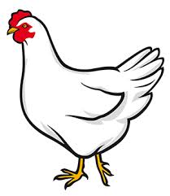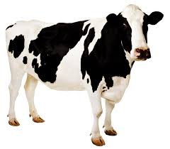
A. 6 B. 7 C. 8 D. 9

26. Using each of the digits 2, 4, and 6 exactly once, how many different 3-digit numbers can you make?

A. 6 B. 7 C. 8 D. 9

27. Six =_______ thirds.

A. 4 B. 6 C. 16 D. 18

28. How many rectangles are in the following diagram?

A. 6 B. 8 C. 12 D. 18

29. I have a five in the ones place. I am greater than 178 but less than 193. What number am I?

A.175 B.179 C.185 D.192

30. 217 minutes after 1:00 pm is how many minutes before 5:00 pm?

A. 13 minutes B. 23 minutes C. 33 minutes D. 83 minutes

BONUS QUESTIONS:

31. Ethan bought a bag of 180 marbles. He gave half of his marbles to Ron and received 27 from Peter, but then accidently lost 19. How many marbles does Ethan have now?

A. 88 B. 98 C. 108 D. 118

32. When three numbers are added in pairs, the resulting sums are 10, 11, and 13. What is the largest of the three numbers?

A. 4 B. 6 C. 7 D. 8

