CIE-USA/DFW
Math Comp 2015
Grade 1
30 questions
Time: 45 Minutes

Note:
- Make sure to write all your answers on the answer sheet. Only the answer sheet will be graded. *
- Each of the questions carries the same weight, so if there is not enough time, work on the easiest problems first.
- PRINT your name and room below.

Name ___________________

Room ___________________

- Which one shows the highest temperature?
A: B: C: D:
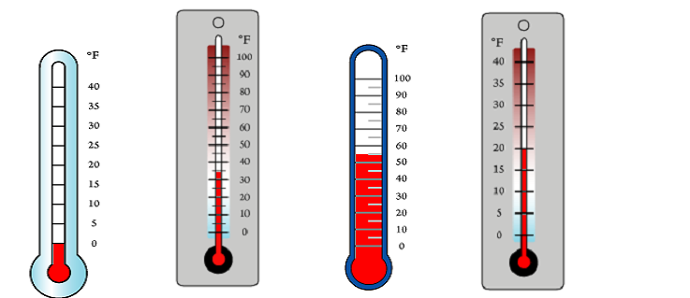

2. Penny is measuring the weight of her pets. The rabbit weighs 9 pounds and the cat weighs 15 pounds. She also wants to know how many pounds her dog weighs. Her Mom told her the dog is 8 pounds more than the rabbit. How heavy is the dog?
A: 23 pounds
B: 24 pounds
C: 18 pounds
D: 17 pounds

3. Cindy has those changes in her pocket and wants to go to buy a dessert. The money she has is shown below.

What is the most expensive dessert she can buy?
A: A Strawberry Sundae costs 1 dollar and 49 cents
B: An apple pie costs 95 cents
C: A hamburger costs 1 dollar and 85 cents
D: A chocolate muffin costs $1.25

4. What is the mode? What is the range?
1, 4, 5, 4, 2, 4, 5, 5, 10, 1, 4
A: Mode: 11; range: 4
B: Mode: 11; range: 9
C: Mode: 4; range: 9
D: Mode: 5: range: 11

5. Complete the number patterns.

____, 21, 28, 35, ______

- 7, 42 B. 14, 43 C. 13, 41 D. 14, 42

6. How many blocks are there in this stack?


- 7 B. 9 C. 10 D. 11

7. Sam paid $4.00 for 8 bananas. How much would he pay for 14 bananas?
- 8 B. 7 C. 12 D. 10

8. It is 6:20 pm. What time will it be 120 minutes from now?
- 7:20pm B. 8:20 pm C. 7:40pm D. 8:40pm

9. Find the pattern and fill in the blanks.
(2, 3), (4, 6), (6, 9), (8, 12) ....

The 6th group is (__, __)

A.(10, 14) B. (10, 15) C. (12, 15) D. (12, 18)

10. The drawings below indicate animals on balances. Which animal is the heaviest?
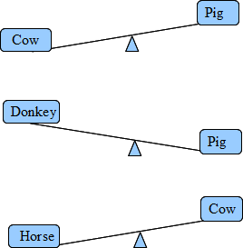

- Cow B. Horse C. Pig D. Can’t tell

11. In the lunch line for pizza, Rakish is 8th counting from the front and 18th counting from the back. How many people are in the lunch line for pizza?

- 26 B. 25 C. 24 D. 28

12. Peter’s birthday is May 16. Ron’s birthday is 27 days later than Peter’s. When is Ron’s birthday?
A: Jun 11
B: Jun 12
C: Jun 13
D: Jul 11

13. How many triangles are there in the following drawing?



- 4. B. 6. C. 8 D. 10

14. Mom is packing the gifts. In each package, there are one book, 2 pencils, and four candy bars. She has 5 books, 9 pencils, and 20 candy bars. How many packages of gift can she make?

A. 4 B. 5 C. 6 D. 3

15. Which number is missing from this sequence?

73, 67, __, 55, 49, 43,

A. 59

B. 60

C. 61

D. 62

16. When Ann was born, Michael was 4. Now Ann is 7 years old. How old is Michael?

A. 9 B. 10 C. 11 D. 12

17. Jerry has 8 boxes of crayons. Each box has 6 crayons.
He has 19 less crayons than Peter. How many crayons
does Peter have?

A. 39 B. 31 C. 29 D. 67

18. How many 3-digit numbers can you make using numbers: 2, 4, and 0? Use each digit only once in the 3-digit number. Do not count numbers that begin with 0.

A. 6 B.5 C. 4 D. 3

19. How many rectangles are there in the following drawing?


A. 9 B.8 C. 6 D. 5

20. To make a flag of the United State of America, you need 3 different colors of fabric. How many colors of fabric do you need to make 10 USA flags?

A. 30 B.10 C. 13 D. 3

21. Kate and Aidan had 42 stickers in all on Monday. On Tuesday, Aidan gave Kate 3 stickers, so they had the same number of stickers. How many stickers did Aidan have at the beginning?

A. 25 B.24 C. 21 D. 18

22. I am a 2-digit number. My 2 digits and the sum of my 2 digits are in sequence. What number am I?

- 23 B.12 C. 34 D. 45

23. Kerry recorded the kind of pets her friends have at home. The results are shown below. How many children have cats at home?
Lucy
John
Darren
Aaron
Susan
Matt
Chris
Julie
Amy
Melody
Michael
Frank
Sharon
Jeff
Linda
Jack
Cat
Dog
A. 3 B.6 C. 9 D. 10

24. Finish the following skip-counting. Which one ___is not 24?

A: 3, 6, 9, 12, 15, 18, 21, ___, 27, 30
B: 4, 8, 12, 16, 20, ___, 28, 32
C: 10, 12, 14, 16, 18, 20, 22, ___, 26, 28
D: 8, 13, 18, __, 28, 33, 38, 43, 48

25. Annie, Ben and Carol go to 3 different elementary schools: Hollister, Dwellington, and Carolina United. Annie does not go to Dwellington or Carolina United. Carol does not go to Dwellington. Which statement below is not true?

- Annie goes to Hollister.

- Ben goes to Dwellington.

- Carol goes to Carolina United.

- Annie goes to Carolina United.

26. Which set of numbers is arranged in order from greatest to least?

A. 490, 489, 487, 489, 478

B. 498, 487, 489, 478, 487

C. 498, 490, 489, 487, 478

D. 498, 489, 490, 487, 478

27. Jim is 23 years old. Mary is five years older than Jessie and nine years younger than Jim. How old is Jessie?

A. 5

B. 9

C. 14

D. 18

28. Eddie had some marbles. His cousin gave him 22 more. He lost 7 of them. Now he has 41 marbles. How many did he start with?
A. 36
B. 29
C. 27
D. 26

29. Sam writes a total of 83 words on 6 blank cards. He writes 14 words on each of the first 5 cards. How many words does Sam write on the last card?
A. 6 B. 12 C. 13 D. 14

30. Jenny had 39 stickers. She buys 5 more and her mom gives her 7 more. If she wants to put 7 stickers on each page of her album, how many pages does she need?

A. 8 B. 7 C. 6 D. 5

Bonus Question:

31. Of all the numbers from 1 to 99, how many times does the digit "1" appear?

A. 21 B. 20 C. 19 D. 18

